EXPENSE TRACKER SYSTEM

OVERVIEW

The Expense Tracker System is a simple, console-based Python application designed to help users record, manage, and monitor their daily expenses efficiently. It allows users to add expense records, view all expenses, search expenses by category, delete expense records, and store expense data permanently using file handling.

PROBLEM ADDRESSED

Managing expenses manually can lead to inaccurate records, overspending, difficulty in tracking expenses, and loss of financial data. This project provides a basic digital solution for organizing and tracking personal expenses efficiently.

MAIN FEATURES

Add Expense Record – Adds new expense records with expense details.

View Expense Records – Displays all recorded expenses.

Search Expense by Category – Finds expenses based on category.

Delete Expense Record – Removes an expense record from the system.

Menu-driven Interface – Allows users to choose operations through a menu.

Input Validation – Prevents incorrect inputs and handles errors safely.

Data Persistence – Stores expense data in a file for future use.

PYTHON CONCEPTS USED

Data Structures

Dictionary – Used to store expense data with keys representing expense attributes.

Lists – Used as values inside the dictionary to hold multiple expense records.

Dictionary of Lists Structure – Each list index represents a single expense record across all fields.

Efficient Data Management – Enables easy addition, searching, and deletion of expense records.

Control Flow

While Loop – Used to repeatedly display the menu until the user chooses to exit.

If / Elif / Else Statements – Used to handle menu selection and decision-making logic.

For Loop – Used to iterate through expense records for viewing and searching.

Functions

show_menu() – Displays the main menu options to the user.

add_expense() – Adds a new expense record.

view_expenses() – Displays all expense records.

search_expense() – Searches expenses using category.

delete_expense() – Deletes an expense record.

save_to_file() – Saves expense data to a file.

exit_program() – Exits the program safely after saving data.

METHODS USED

List Methods

append() – Used to add new expense records to the list.

pop() – Used to remove expense records from the list.

len() – Used to determine the number of expense records.

Dictionary Methods

keys() – Used to access all dictionary keys.

values() – Used to access all dictionary values.

get() – Used to safely retrieve values from the dictionary.

String Methods

strip() – Used to remove extra spaces from user input.

title() – Used to format category names properly.

EXCEPTION HANDLING

try / except Block – Used to handle invalid user input such as entering text instead of numbers.

ValueError Handling – Prevents the program from crashing due to incorrect data types.

User-Friendly Messages – Displays clear error messages when an exception occurs.

Smooth Program Execution – Ensures the program continues running even after input errors.

FILE HANDLING AND LIBRARIES

File Handling – Expense data is saved to and loaded from a file using the with open() statement.

Read and Write Operations – Files are opened in read ("r") and write ("w") modes to manage data persistence.

Data Persistence – Ensures expense records are retained after program execution ends.

Libraries Used – Standard Python libraries along with pandas and numpy are used.

HOW TO RUN

Open Jupyter Notebook or Python environment.

Run the Expense Tracker System file.

Run all cells or the main program cell.

Follow menu instructions displayed on the screen.

INPUT AND USAGE GUIDELINES

Numeric Inputs – Expense ID and Amount must be entered as numbers only.

Text Inputs – Expense Category and Description should be entered as text.

Menu Selection – Users must select menu options using the corresponding numbers.

Invalid Input Handling – The program displays an error message if incorrect input is entered.

Exit Procedure – Users should choose the exit option to safely close the program and save data.

FILE AND DATASET DETAILS

Data File Name – Expense records are stored in a file named expenses.txt.

File Location – The data file is stored in the same folder as the Python program.

Stored Fields – Expense ID, Date, Category, Description, Amount.

File Creation – If the file does not exist, it is created automatically when data is saved.

Data Loading – Expense data is loaded from the file when the program starts.

TESTING AND SCREENSHOTS

Useful test scenarios

Viewing all expense records.

Adding a new expense record.

Searching expenses by category.

Deleting an expense record.

Entering only numeric values where required.

ASSIGNMENT FIT AND EXTRAS

Meets Assignment Requirements – Fully satisfies all Python mini-project guidelines.

Real-World Application – Addresses a practical problem in personal expense management.

Structured Programming – Uses functions, loops, and conditionals effectively.

Error Handling – Includes exception handling to manage invalid inputs.

Data Persistence – Implements file handling to save and load expense records.

Easy to Extend – Can be enhanced with features like monthly reports or category-wise summaries.

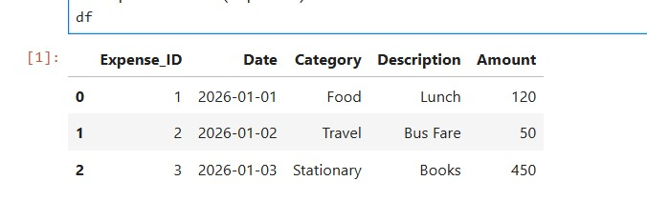

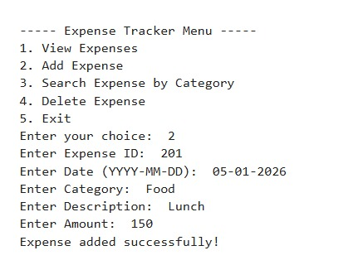
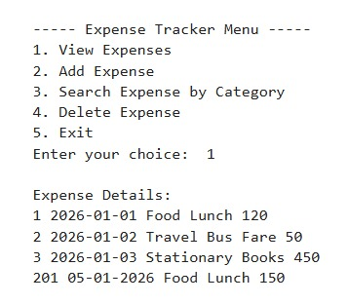
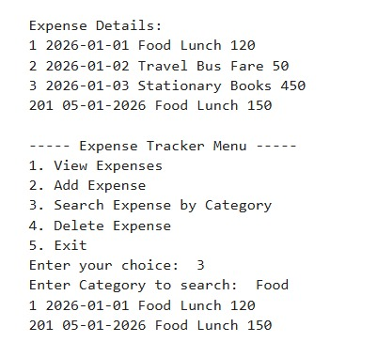
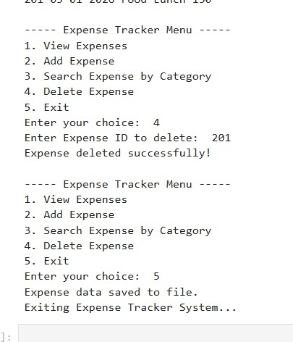

AUTHOR DETAILS

Name: Anusha DS
USN: 1BG24BA013
Course: Python Programming
Project: Expense Tracker System
Domain: Personal Finance / Expense Management

